**SPOOKTACULAR HALLOWEEN DISCO**

**Ladybridge P.T.F.A. present…….**

Thursday 1st November 2018

6.00pm until 8.00pm

£3 per ticket – includes pizza slice.

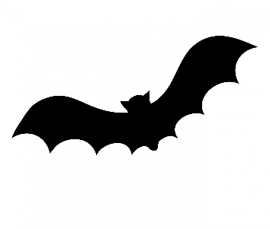

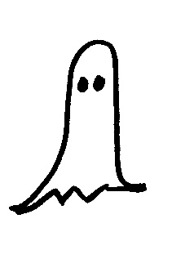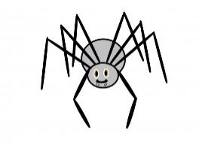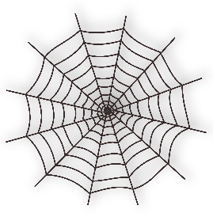

**Tickets on sale NOW from the school office!!**

**(numbers limited by hall capacity)**

**Punch Balloons**

**Glow Sticks**

**Games**

**Tuck Shop**

**Lucky Dip**

**Bring A Carved Pumpkin – Prizes To Be Won!!**

**Refreshments**

**Fancy Dress Competition**