

**School Update**

**29th March 2019**



**Thursday 4th April**

Easter Egg Bingo 6-8pm

Eyes down at 6.15pm

Tickets are on sale now, at £3 each, from the school office

**Friday 5th April**

School Closes for Easter

**Tuesday 23rd April**

School reopens for Summer Term

**Saturday 27th April**

Hollywood Bollywood Event

(Look out for the letter coming home next week with more details)

**Thursday 2nd May**

Polling Day – **SCHOOL OPEN**

**Friday 10th May**

Year 4 Class Assembly

**PTFA - Treat Fridays **

**Chocolates & sweets & drinks for sale in the playgrounds after school (weather permitting)**



* Thank you to all of the children who came to the secrets room. We sold 117 gifts. The children thoroughly enjoyed choosing their gifts.
* Does anybody have any unwanted gifts they could donate to the PTFA to be used for raffle prizes? If so, please drop them at the school office, thank you.

**Are you warming up?**

After a great start on our new daily mile track (on the KS2 field), the recent wet weather meant that work had to pause. But, the good news is that the contractors have been back on site this week and are busily constructing and laying the rest of the track. It will be ready for use once we return after the Easter Holiday

Once the track is complete, we hope that pupils will be keen to use it for walking and running, during their breaks and at lunchtime. However, we're also keen to look at how we can make use of it as part of the 'daily mile' initiative, in order that all classes can have the opportunity to improve their fitness and be more physically active every day.

Watch this space for an update.

**The Winners of the Class Attendance**

**Award for this term are…**

**2B & 6L**

**2B and 6L may come to school in non-uniform on Friday 5th April, for a popcorn and film party!**

**Attendance Matters**

**Attendance For**

**this week**

**97.1%**

*Class with the best attendance****:***

**4L -99.3%**

*Most punctual class:*

**5B and 6L - 100%**

**Remember Attendance Matters; Be in School All Day,**

**Every Day.**

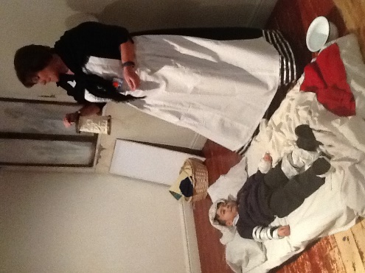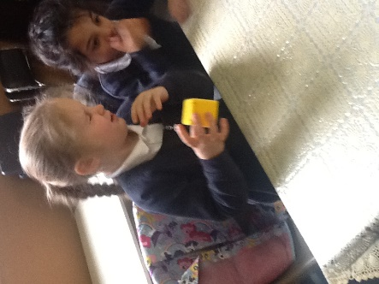

**Each week, we will focus on work undertaken by a different class. This week it is the turn of 1B…**

This week we have been learning about Florence Nightingale and Mary Seacole, who improved conditions in hospitals. We had a great time visiting Thackray museum, where we met 'Florence', travelled back in time, 'cleaned' Scutari hospital and tended to a wounded soldier!

**Parents, please note…**

* **Children should not be on the new play equipment in the KS1 playground, including the tyres, before or after school. This includes younger and older siblings who don’t attend Ladybridge Primary School.**
* **Thank you to all the parents who, after last week’s newsletter, are now sending ‘plain water’ only in their children’s water bottles.**
* **We have a new parent Governor. Thank you to everybody who applied and all those who voted. Mrs Shameem Patel was successfully elected, congratulations.**

**Rounders Club**

Miss Whittingham will be having aRounders Clubafter the Easter Holidays. If you would like to book your child a place in rounders club on a Tuesday after school, 3.30pm until 4.30pm, please do so on the parents’ evening booking system. A link to the parents’ Evening booking system can be found on the school website, see <https://www.ladybridgeprimaryschool.co.uk/parents-information/parents-evening> Booking will open today (Friday) at 7pm and close on Tuesday 23rd April at 9am. The school office will be happy to help to book your child a place in the club if for any reason you cannot.

Please note, Miss Whittingham’s film club will finish at the end of this term.

You can do any or all… the choice is yours!

**Next week’s word of the week is… Humanitarian**

**The Weekly Mission, if you choose to accept it!**

1. Complete the word of the week challenge.
2. It’s Mother’s Day on Sunday, do something nice for your Mum.
3. Go on ‘Life’ and post your thoughts and ideas.

If school needs to close due to severe weather conditions, we will text to advise parents and carers. It will also be put on the Local Authority website - this can be checked at [www.bolton.gov.uk](http://www.bolton.gov.uk)

**Useful Information**

**School telephone number:**

01204 333646

**School email address:**

office@ladybridge.bolton.sch.uk

**School website:**

[www.ladybridgeprimaryschool.co.uk](http://www.ladybridgeprimaryschool.co.uk)

Please ensure that you update the school office with any changes to your child’s details.

**PARENT VIEW**

**We would like your thoughts on our school, at any time…** Please visit https://parentview.ofsted.gov.uk/ and click on the ‘Give Your Views’ link to tell Ofsted what you think about your child’s school.You can visit the Parent View website at any time and complete the questionnaire. Parent View is accessed by Ofsted to check how parents feel about the school.