



**Monday 14th-Thursday 17th May**

Year 6 SATs Week

**Wednesday 23rd May**

New Parents’/Carers’ Open Evening: 6:00pm (*Reception Pupils Starting September 2018*)

**Friday 25th May**

Reception: Joint Class Assembly: 9:15am, Crèche Available

**Friday 8th June**

PTFA Father’s Day Secrets’ Room

**Thursday 14th June**

Year Five: Joint Class Assembly: 9:15am, Crèche Available

**Wednesday 20th June**

Parents’ Forum – 6.30pm

All Welcome

**PTFA - Treat Fridays** 

Chocolates & Sweets (30p) & Drinks (20p) for Sale in the Playgrounds After School (weather permitting)

**School Update**

**4th May 2018**

**ASSEMBLY MISSIONS!**

Each week, as part of Monday’s whole school assembly, the children (Y1-Y6) are introduced to the new word of the week and assembly theme. The assembly themes and words are often deliberately challenging and thought-provoking, so the children are encouraged to think and connect their learning to something new. At the end of Monday’s assembly, the children are set a weekly mission. The mission is an opportunity for children to find out more about something related to the theme (eg. researching, asking questions, finding something, making something, etc). So, please ask your child(ren) questions after Monday’s assembly…

**Check List**

* My child can tell me what the ‘theme of the week’ is, what they think it means and why they think we have chosen it as our assembly theme.
* My child can tell me about the ‘word of the week’ and what is means* (and they can even use it in a sentence).
* My child can find the connection between the assembly theme and the word of the week*
* MY child can tell me what the weekly assembly mission is.
* My child ‘accepts the mission’ and has a go at completing it.

\**Some of the younger children are likely to find this particularly challenging*

**Mr Watson, Headteacher**

**Useful Information**

**School telephone number:**

01204 333646

**School email address:**

office@ladybridge.bolton.sch.uk

**School website:**

www.ladybridgeprimaryschool.co.uk

@LadybridgeP

**Attendance Matters**

School Attendance Target = 97%

**Actual Attendance**

For week ending 30/3/18 **95.62% ☹**

*Class with the best attendance:* **3L = 100% ☺**

*Most punctual class:* **Giraffes = 99.7% ☺**

**Remember Attendance Matters; Be in School All Day, Every Day.**





This week, 3B have been working very hard to consolidate our knowledge on time, using both digital and analogue clocks. It has been tricky, but we have been resilient and we are making great progress! We have also been studying volcanoes in Geography as part of our dinosaurs topic. We have learnt about how a volcano is formed, and held a class discussion about the pros and cons of living near a volcano.  
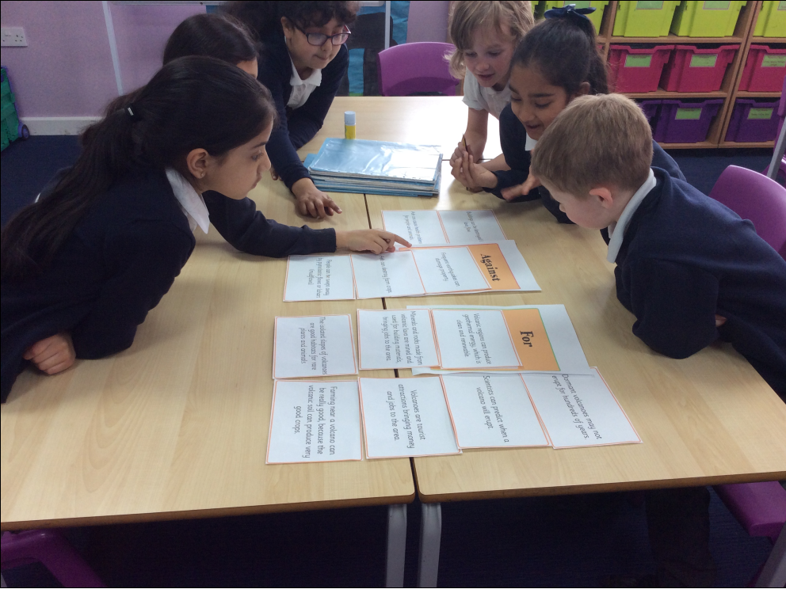

**Class Focus: 3B**

-

**Each week, we will focus on work undertaken by a different class. This week it is the turn of 3B…**



**PARENT VIEW**

**We would like your thoughts on our school, at any time…**

Please visit https://parentview.ofsted.gov.uk/ and click on the ‘Give Your Views’ link to tell Ofsted what you think about your child’s school.You can visit the Parent View website at any time and complete the questionnaire. Parent View is accessed by Ofsted to check how parents feel about the school.



**Labracadabra**

**Before and After School Club**

If you have any toys you no longer use, the children at Labracadabra would love to have them. They have particularly requested the following things, but we would be grateful for any toys in good working order.

* Bikes
* Scooters
* Safety helmets and protective wear
* Car mats/carpets
* Cars
* Dolls
* Doll accessories (clothes, prams, cots, bottles etc.)
* Pool table
* Ping pong table

Thank you!



**Father’s Day Secrets’ Room**

will be held on

**Friday 8th June 2018**

Look out for the letter coming home with your child soon.



**September 2018 Reception**

We still have a few places available for our new reception class in September. If you have a child who will be 4 years old before the end of August, and you have not yet been allocated a school place, or you are not happy with your allocated school place, please feel free to call into the school office to discuss it with a member of the school office team, they will be happy to help.