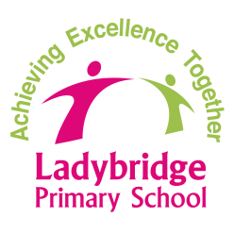

**Post-Ofsted Update**

**13th July 2018**

**Ofsted said…**

**we Require Improvement**

**So, what have we achieved so far…**

4. EYFS (Early Years Foundation Stage)

***This year, 76% of Reception children have attained the good level of development, which represents good progress from starting points that were below those found typically particularly in the learning areas of Communication and language, Literacy, Understanding the World and Expressive arts and design.***

***Learning journals and books show progress across the 7 areas of learning, and moderation activity has taken place in-house and with the local cluster group of schools.***

***The teaching and learning of reading and writing have been underpinned by solid phonics teaching. As a result, children are confident to read words in the environment and apply their phonic knowledge to write captions and sentences. Letter formation is good and many children use simple punctuation. Children are engaged to write through work based on themes and topics that spark their interest, such as dinosaurs and mermaids.***

***Teaching staff are well prepared to lead guided sessions and interactions are focused and help children to make progress. Staff are flexibly deployed to support children’s learning throughout the provision, indoors and outdoors and they interact in a playful way to extend learning and note key achievements.***

***The outdoor area has been enhanced with new structures and planting. Children enthusiastically use the area, safely climb and jump off the bridge, experiment with water in the tiny stream and learn to hula-hoop. Co-operative play flourishes as children work together to build a huge volcano and form a band using instruments on the stage.***

***Continuous provision provides opportunities for children to develop and apply skills and knowledge across the EYFS curriculum and ‘Choosing Challenges’ have been introduced to encourage children to try a wide range of experiences and increase motivation and challenge.***

***Children attend well and follow the agreed classroom rules. They are independent and access the resources they need, tidying up after themselves.***

2. + 3. Outcomes (the ‘wider’ curriculum, including challenge + reading, writing and maths)

Ten teachers, across school, are all currently leading whole school improvement projects, which focus on areas identified from the Ofsted report.



***The Local Authority recently carried out a one day review of the whole school. Their findings have been included in this update, and are written in bold italics.***

Our 7 point post-Ofsted action plan has now been updated and replaced by a more succinct 5 point plan focusing on:

1. Curriculum (design and progression)
2. Outcomes (the ‘wider’ curriculum, including challenge)
3. Outcomes (reading, writing and maths, including challenge)
4. EYFS (Early Years Foundation Stage)
5. Teaching, Learning & Assessment

2. Middle Leadership + 5. The Wider Curriculum

We have re-organised the leadership of subjects within the wider curriculum, which will provide more support for leaders. Shared roles will enable leaders to carry out more monitoring and checking, so that more improvements can be made quickly.

5. The Wider Curriculum

Teachers are continuing their review and redesign of the curriculum (which we began Sept’17) with a focus on ensuring greater:

- emphasis on skills progression;

- choice and independence;

- opportunities to work at greater depth/ greater challenge;

- pupil engagement and interest (through the use of new learning challenge questions.

These changes are due to be implemented from May. The impact of this will be monitored by subject leaders.

*1.– 5. Leadership*

***Leaders have used the support of experienced professionals to help identify next steps and secure improvement.***

5. Teaching and leaning

***The profile of teaching observed today in English and mathematics lessons is good.***

***In writing lessons, teachers model the approach well and make explicit the necessary spelling, grammar and vocabulary to be used. Good prompts support pupils’ ideas. Teachers provide useful feedback at the point of learning and pupil use this in their writing.***

***Teaching assistants make a positive contribution to pupils’ learning and are suitably skilled to teach groups and classes under the direction of the class teachers****.*

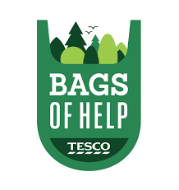

2. + 3. Outcomes (the ‘wider’ curriculum, including challenge + reading, writing and maths)

As part of the new wider curriculum (and in response to analysis of pupils’ reading comprehension, we are placing a greater emphasis on VOCABULARY. Pupils will develop a broader knowledge and understanding of vocabulary, as well as being able to accurately use and spell more challenging words. Actions will include:

- Word windows: these have already begun (key vocabulary from the wider curriculum is added to classroom windows throughout the week, in order that pupils become more familiar with it and are able to remember it.

- Regular vocabulary tests: these will be introduced in the Autumn term, and will take place at the end of a unit of work/learning challenge.

- Word of the week: an increase in the types of tasks (and expectations) that all pupils will be expected to participate in (in the Autumn term).

1. Curriculum (design and progression)

A new curriculum map is now in place which has supported curriculum leaders and teachers in seeing a clear progression of skills and knowledge.

Each topic/learning theme will be introduced with a Learning Challenge eg Y5 History: ‘Would you be hired or fired as a Victorian apprentice?’ We will send out the curriculum map and Learning Challenges at the start of the Autumn term, so parents are aware of the year ahead and are able to support learning at home.

From September, French and music will be taught on a more regular basis.

5. Outcomes (the ‘wider’ curriculum, including challenge)

The teachers of next year’s Y5 and Y6 also have i-pads, enabling them to access i-pad/ ‘apple teacher’ training over the summer, in order that digital technology can become an integral part of teaching and learning.

3. Outcomes (reading, writing and maths, including challenge)

***Pupils say they enjoy lessons when they are challenged even though it may be difficult at times. They talk about the recent introduction of “Strive to Dive” activities, which they complete when other work is finished.***

Examples of the dive can be seen in corridor displays and in pupils’ books. This is indicated by this dive symbol:



2. Outcomes (the ‘wider’ curriculum, including challenge)

We have now purchased individual i-pads for all of next year’s Year 6 and Year 5 pupils. This will support teachers and pupils in being able to provide learning opportunities that support greater choice and independence.

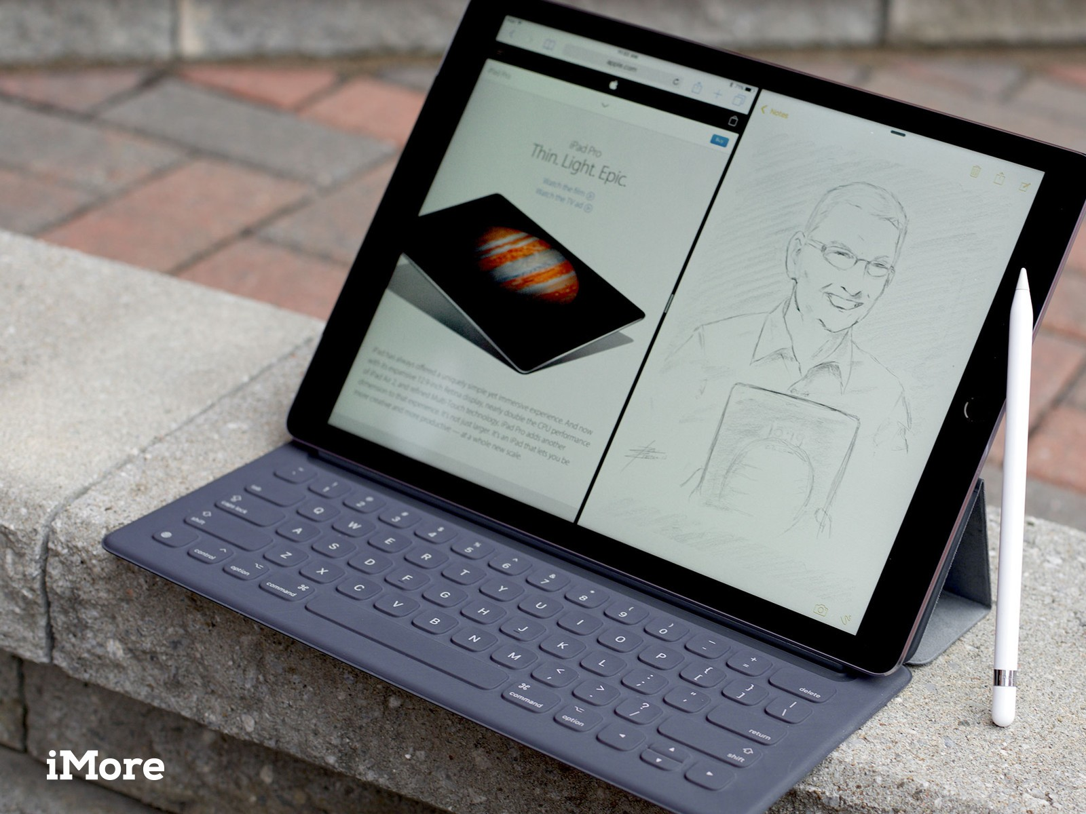

*1.– 5. Leadership*

***Leaders’ evaluations of teaching quality match those seen today by the review team.***

***The post-Ofsted plans have provided useful direction and have ensured key aspects of development work have been completed.***

***Senior leaders’ observations of learning and records of pupil progress meetings are detailed and focus well on the progress made by pupils.***

***Leaders make sensible judgements in their self -evaluation summary and the development points inform development plans.***

***The governors continue to know the school well because they see it when it is in operation. Governors challenge leaders in meetings asking questions about different pupil groups. They are clear about the school’s current position, including that for disadvantaged pupils and are confident newly created plans will quickly address the areas for improvement identified by Ofsted, which will be checked when they visit school and in meetings next term.***