*Copyright © 2015 Ladybridge Community Primary School. All rights reserved.* *This work is registered with the UK Copyright Service:*  *Registration No:284693450*

Friday 5th October

Dear Parent/Carer,

Please find below a list of homework opportunities, available across **Key stage 1.**

**Homework Books:**

Every child in Key Stage 1 will receive a homework activity sheet at the start of every half term. This sheet will relate to a current theme/topic of learning in your child's class. There will be a range of activities your child can choose from, and **at least four** should be completed throughout each half term. You will be notified by your child's class teacher when these books need to be handed in.

**Spellings:**

If your child is in Year 1, they will be given 10 new spellings every week; 15 if they’re in Year 2. It is important to focus regularly on these words, because they include taught phonics sounds, as well as high frequency and common exception words, which are often spelt incorrectly. Weekly spelling tests will take place in school. After the weekly test, your child’s spelling book will be returned. Any incorrect spellings should be practised further at home. This book will also contain your child’s new spellings.

Each child will also receive their own personal login for **'Spelling Shed',** where they are able to play games and practise their spellings!

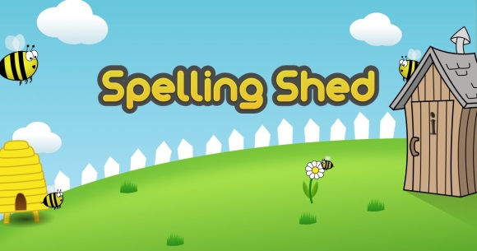

**Reading:**

Daily reading at home is expected. We ask that parents please sign their child's diary, in order to inform their class teacher of what's been read at home. Books will not be changed without a signature. When reading with your child, it is important that you ask them questions about the book they have read. This will improve both fluency and comprehension.

**Times Tables:**

TT Rockstars is a fun interactive game, where each child can create their own rock star; they are able to earn rewards and prizes for their character. Each child will have their own login for TT Rock Stars.

**This is available for Year 2 only, due to the content of the national curriculum.**



**My Maths:**

Every child's 'My Maths' account throughout key stage one has now been amended, to allow them to access every task from their current year group; children are now able to login and access these activities. Please note that weekly 'My Maths' activities will not be set in any year groups, these activities have been opened and are available to access as an extra, if you wish for your child to do so.



**All user names and passwords can be found in your child’s diary.**

If you have any questions or require any further information please don't hesitate to contact your child's class teacher.