*Copyright © 2015 Ladybridge Community Primary School. All rights reserved.* *This work is registered with the UK Copyright Service:*  *Registration No:284693450*

Friday 5th October

Dear Parent/Carer,

Please find below a list of homework opportunities, available across **Key stage 2.**

**Homework Books:**

Every child in Key Stage 2 will receive a homework activity sheet at the start of every half term. This sheet will relate to a current theme/topic of learning in your child's class. There will be a range of activities your child can choose from, and **at least four** must be completed throughout each half term. You will be notified by your child's class teacher when these books need to be handed in.

**Spellings:**

Your child will be given 5 new spellings every week. It is important to focus regularly on these words, because they are high frequency words and are often misspelt. They are also likely to be included in the spelling aspect of the Grammar, Punctuation and Spelling tests. Weekly spelling tests will take place in school. After the weekly test, children will highlight any spellings spelt correctly, in the column on the left. Incorrect spellings will not be highlighted, and will need to be practised further at home. The 5 spellings in the right column, will be that week’s new spellings.

The below table will be stapled into your child's diary, on a weekly basis,

|  |  |
| --- | --- |
| **Last Week’s Spellings** | **This Week’s Spellings: 11.9.18** |
| believe  beneath  breathe  breath  before | calendar  caught  century  centre  certain |

Each child will also receive their own personal login for **'Spelling Shed',** where they are able to play games and practise their spellings!

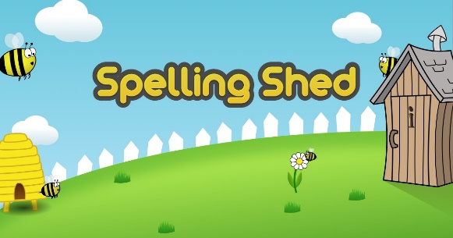

**Reading:**

Daily reading at home is recommended. We ask that parents please sign their child's diary, in order to inform their class teacher of what's been read at home. Books will not be changed without a signature. When reading with your child, it is important that you ask them questions about the book they have read. This will improve both fluency and comprehension.

**Times Tables:**

Times tables are an essential part of Maths, because of this we encourage the use of TT Rock Stars at home. TT Rockstars is a fun interactive game, where each child can create their own rock star; they are able to earn rewards and prizes for their character. Each child will have their own login for TT Rock Stars.



**My Maths:**

Every child's 'My Maths' account throughout key stage two has now been amended, to allow them to access every task from their current year group; children are now able to login and access these activities. Please note that weekly 'My Maths' activities will not be set in any year groups, these activities have been opened and are available to access as an extra, if you wish for your child to do so.



If your child doesn't have access to a computer at home, there will be an opportunity, once per week, where they are able to visit the computing suite at lunchtime. During this time, the children will be able to use the computer for any homework purposes. i.e. to login to 'TT Rocks Stars' or 'Spelling Shed'.

**All user names and passwords can be found in your child’s diary.**

If you have any questions or require any further information please don't hesitate to contact your child's class teacher.