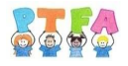
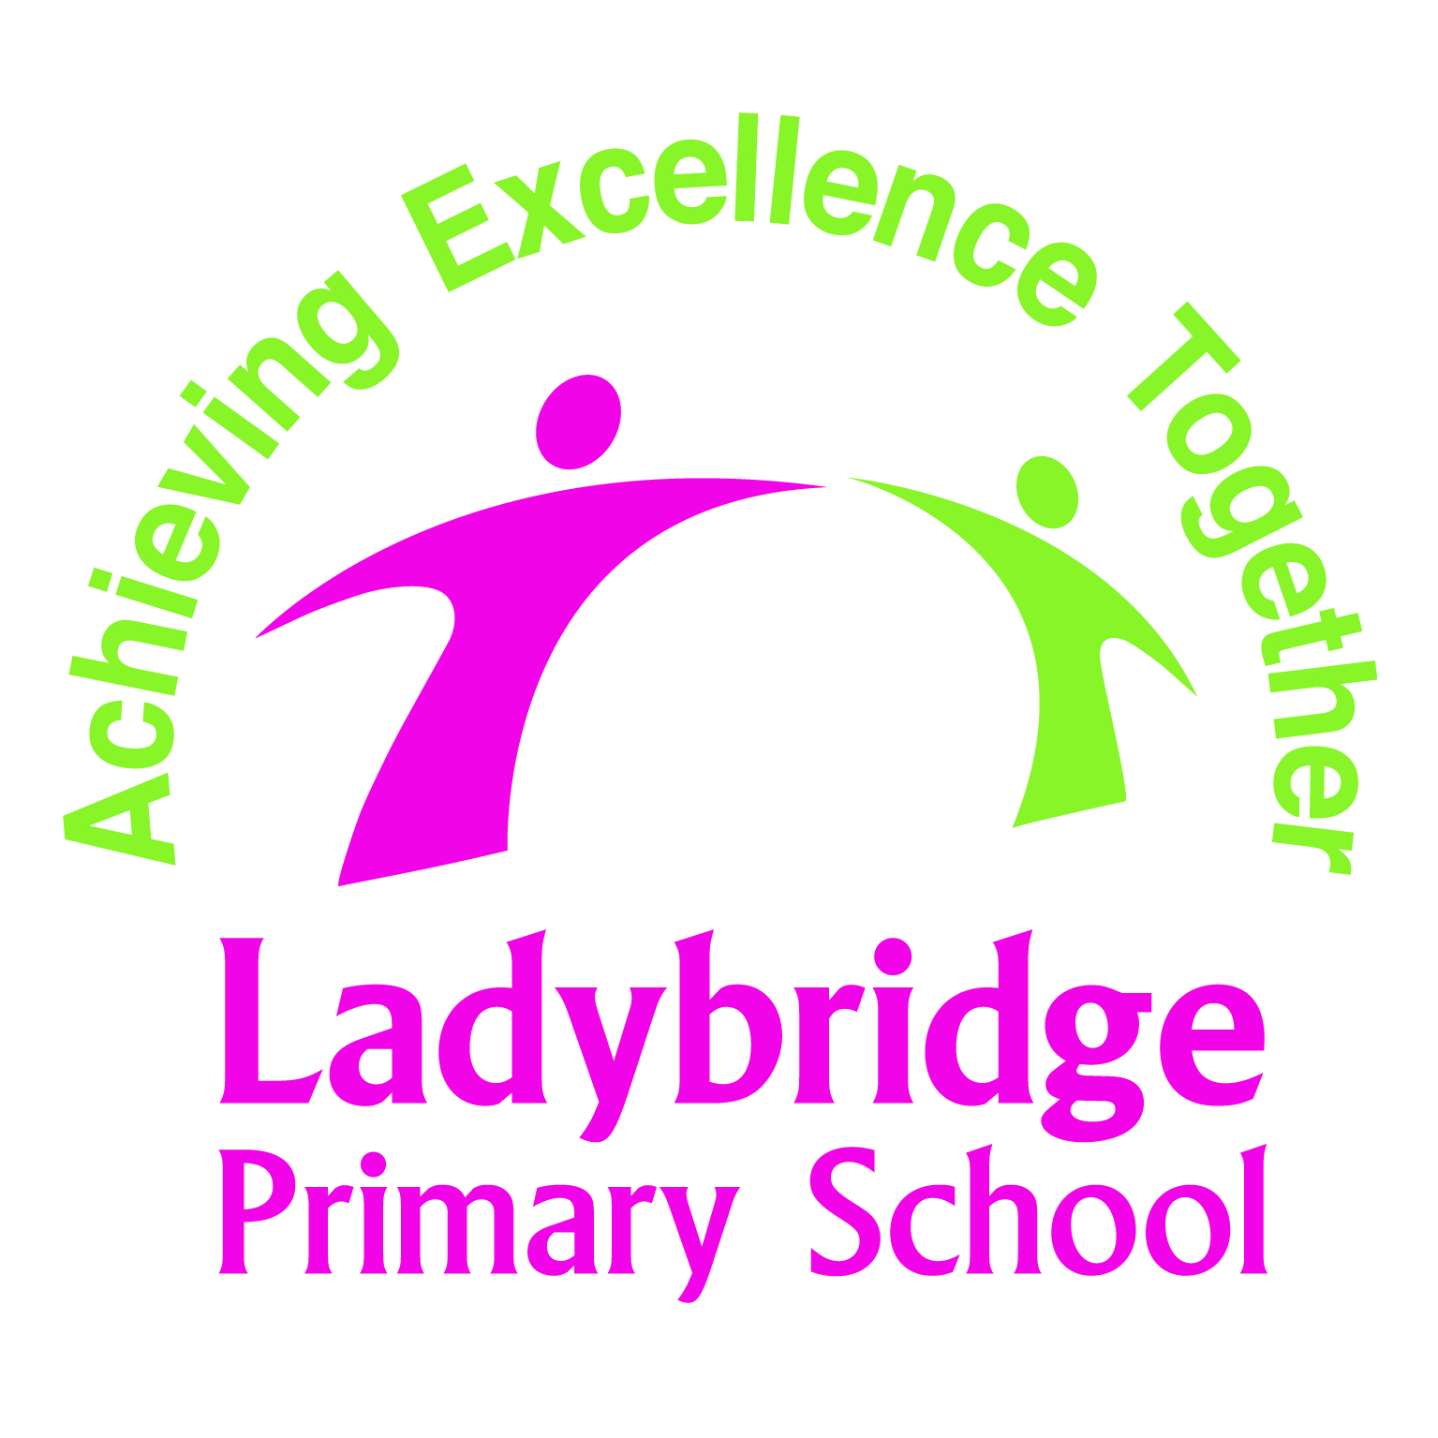

The “Christmas Secrets’ Room” is back!
For just £3.00 your child can select a present for members of their family, friends, neighbours, teachers, etc.
The Secrets’ Room will be open on Friday 16th December, during the school day, when your child will come and choose their presents. All the presents will be wrapped and labelled ready for your child to take home and put secretly under the Christmas tree!
We buy a selection of presents, ranging from children’s toys, books and teenage gadgets to adult bath sets, candles, perfume, jewellery, aftershave sets and lots more.
Don’t forget, it is your child’s choice which makes it extra special and gives them independence!
If you would like your child to buy presents from the PTFA Secrets’ Room, please fill in the form below and return it in an envelope with £3.00 per present by Friday 9th December.
We will keep this form and return it to you on Friday 16th December, when your child brings home their present(s).
Love from the PTFA
- ---------------------------------------------------------------------------------------------------------------
Child’s Name……………………………………………… Class………………………………………………………
Name of Recipient | Male  (Years) |  |  |  | Female  (Years) |  |  |  | Infant (Years)
 | 3 - 6 | 7 - 11 | 12 - 16 | Adult | 3 - 6 | 7 - 11 | 12 - 16 | Adult | 0-3
E.g. Grandad John

Total number of presents Total amount enclosed at £3.00 per present
If your child has a sibling(s) in another class that is/are buying presents from the Secrets’ Room, please write their name(s) & class below so we can ensure they choose different presents.

Please return your completed form, together with full payment, to the School Office by 9th December.

